Location | Date | Topic |  | Evening activity
Harbor View House, Prospect Harbor | April 10-13 |  | Flower Portraits or Cooking | Gordon Ward Original Music
Campobello, NB, CA | June 5-8 |  | Watercolors or Cooking | Katherine Moller, Celtic Fiddle
Harbor View House, Prospect Harbor | Sept 11-14 |  | Watercolors or Cooking | Gordon Ward Original Music
Campobello, NB, CA | Oct 9 – 12 |  | Watercolors or Cooking | Katherine Moller, Celtic Fiddle
Bath | Nov 6 - 9 |  | Drawing AND cooking | Museum trips, artist films

---------------------------------------------------------------------------------------------------------------------

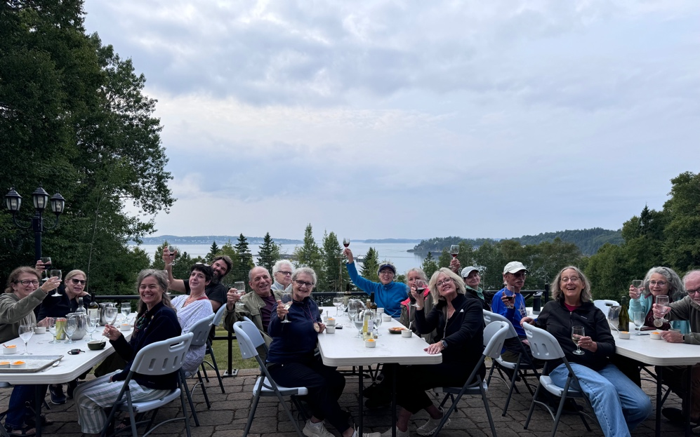

Acadian Arts Retreat Asian Fusion Cooking at Roosevelt Campobello International Park, New Brunswick, Canada
with Chris Toy
OCT
June 5-8, or Oct 9 – 12
$695
Join chef and cookbook author Chris Toy for a hands-on culinary retreat on Campobello Island. Learn global recipes blending Asian, European, and American flavors using local ingredients. Enjoy all-inclusive meals, evening activities, and exclusive lodging in historic Victorian cottages within Roosevelt Campobello Park. Cook, learn, and savor every moment! - “I learned so much that Chris taught me, and the recipes were attainable."
-------------------------------------------------------------------------------------------------------------------

Acadian Arts Retreat Watercolor Painting at Roosevelt Campobello International Park, New Brunswick, Canada
with Mary Laury
June 5-8, or Oct 9 – 12
$695
OCT
Experience the charm of Campobello Island in a creative retreat led by watercolor artist Mary Laury. Settle into historic Victorian cottages within the 3,000-acre Roosevelt Campobello Park, where coastal light and sea air inspire every brushstroke. Enjoy all-inclusive meals, guided painting sessions, and the company of fellow artists. Whether beginning or experienced, you’ll find space to create, reflect, and be renewed by the island’s quiet beauty. - “Mary is a wonderful guide and a gifted teacher.”

---------------------------------------------------------------------------------------------------------------------
---------------------------------------------------------------------------------------------------------------------

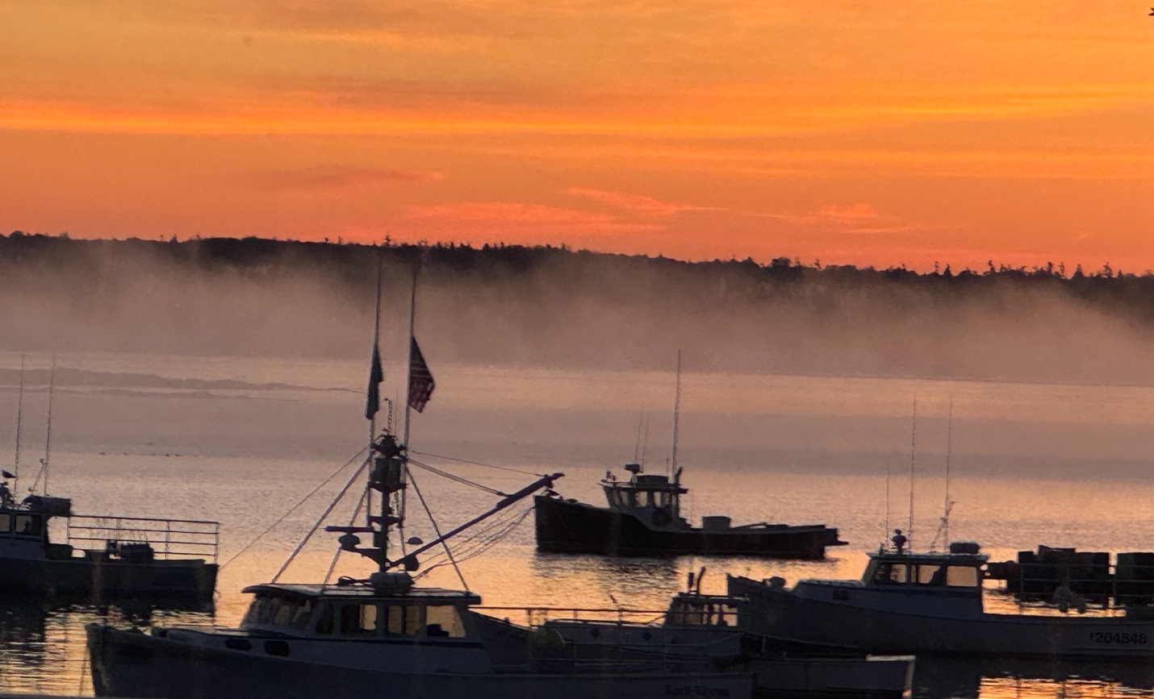
Acadian Arts Asian Fusion Cooking Retreat at Harbor View House in Prospect Harbor, Maine
with Chris Toy
SEP
April 10-13 or Sept 11-14
$695
Join chef and author Chris Toy for a hands-on Asian-fusion cooking retreat near Acadia National Park at Schoodic Point, Maine. Create and savor delicious meals, relax in a charming Victorian inn, and enjoy special evening events—including a private concert with Gordan Ward. A welcoming, immersive culinary escape!
“I learned so much from Chris that I can use immediately at home in my own kitchen.”
---------------------------------------------------------------------------------------------------------------------
Acadian Arts Watercolor Painting Retreat at Harbor View House, Prospect Harbor, Maine - with Mary Laury
April 10-13 or Sept 11-14
$695
Discover inspiration by the sea in Prospect Harbor, Maine. Join renowned watercolorist Mary Laury for a hands-on creative retreat at the Harbor View House. Explore new watercolor techniques, paint in a serene coastal setting, and share your work among fellow artists. Enjoy thoughtfully prepared meals and a private evening concert by Gordan Ward—an enriching blend of artistry, connection, and the quiet rhythm of the Maine coast.
-----------------------------------------------------------------------------------------------------------
---------------------------------------------------------------------------------------------------------------------

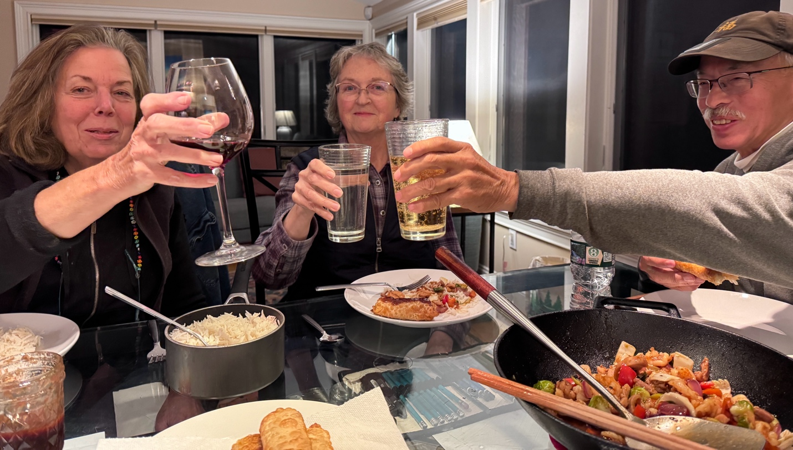
Acadian Arts Drawing and Cooking, Bath, Maine
with Mary Laury and Chris Toy
SEP
Nov 6-9
$695

Immerse yourself in an inspiring course along Maine’s coastline. Engage in guided drawing lessons, hands-on culinary workshops, and curated museum visits. Strengthen your artistic skills, deepen observation, and connect with fellow creators in a thoughtful program blending learning, exploration, and the quiet beauty of the sea. – “This has been like a place between worlds, and a time to reconstitute, and recombobulate around new experiences that feed my soul.”

